1.Scheme_reguser

create table scheme_reguser (RegUId int, ActiveScheme varchar(255) , primary key(RegUId), foreign key (ActiveScheme) REFERENCES scheme(SchemePlan ), foreign key (RegUId) REFERENCES Registered_Users(RegUId));

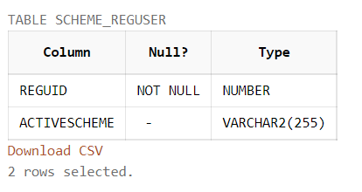

insert into scheme_reguser values(1008,'Basic_months');

insert into scheme_reguser values(1011,'Standard_months');

insert into scheme_reguser values(1001,'Premium_months');

insert into scheme_reguser values(1007,'Premium_months');

insert into scheme_reguser values(1003,null);

insert into scheme_reguser values(1014,'Standard_months');

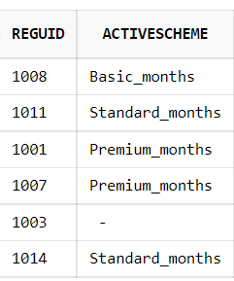

2.Scheme

create table scheme (SchemePlan varchar(255) , PriceOfScheme DECIMAL (10,2) NOT NULL, primary key(SchemePlan));

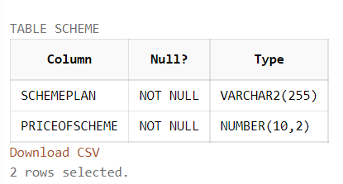

insert into scheme values('Basic_months',500.00);

insert into scheme values('Standard_months',1500.00);

insert into scheme values('Premium_months',5000.00);

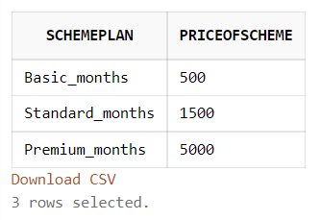

3.Renewal

create table renewal(RegUId int,SchemePlan varchar(255) not null,Renewal_ID int, ExpiryDate date not null, primary key(RegUId,Renewal_ID),foreign key(Renewal_ID) references Renewal_info(Renewal_ID) ,foreign key(SchemePlan) references scheme(SchemePlan),foreign key (RegUId) REFERENCES Registered_Users(RegUId));

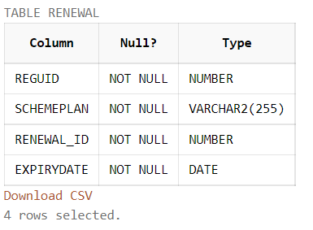

insert into renewal values(1001,'Premium_months',283, TO_DATE('17/01/2016', 'DD/MM/YYYY'));

insert into renewal values(1003,'Standard_months',584, TO_DATE('12/04/2020', 'DD/MM/YYYY'));

insert into renewal values(1007,'Premium_months',789, TO_DATE('05/01/2022', 'DD/MM/YYYY'));

insert into renewal values(1008,'Basic_months',333, TO_DATE('28/02/2021', 'DD/MM/YYYY'));

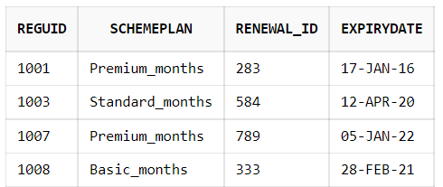

4.Renewal_info

create table Renewal_info(Renewal_ID int,Renewal_date date NOT NULL, primary key(Renewal_ID));

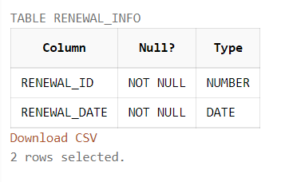

insert into Renewal_info values(283, TO_DATE('17/12/2015', 'DD/MM/YYYY'));

insert into Renewal_info values(584, TO_DATE('12/03/2020', 'DD/MM/YYYY'));

insert into Renewal_info values(333, TO_DATE('30/01/2021', 'DD/MM/YYYY'));

insert into Renewal_info values(789, TO_DATE('05/12/2021', 'DD/MM/YYYY'));

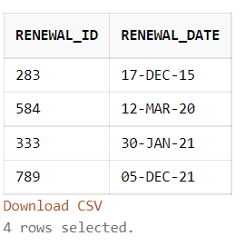

5.Payment

create table Payment(Transaction_ID int,RegUId int,SchemePlan varchar(255) not null,primary key(RegUId,Transaction_ID),foreign key(SchemePlan) references scheme(SchemePlan), foreign key (RegUId) REFERENCES Registered_Users(RegUId), ), foreign key (Transaction_ID) REFERENCES Paymentinfo(TransactionId));

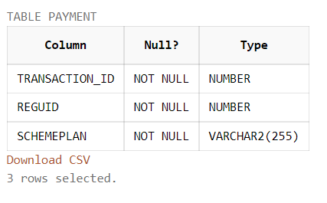

insert into Payment values(3582,1001,'Premium_months');

insert into Payment values(9003,1003,'Standard_months');

insert into Payment values(6843,1007,'Premium_months');

insert into Payment values(5738,1008,'Basic_months');

